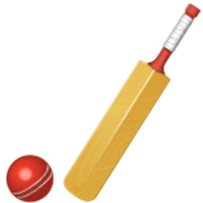
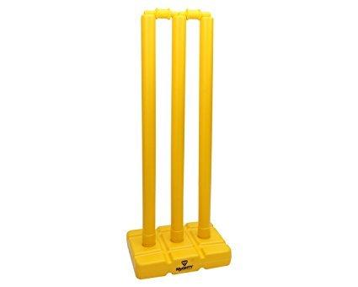
The Rules of Cricket

Cricket bat and ball
Cricket Wicket

A match is played between two teams.
One team fields while the other team is the batting side.
The fielding team bowls the cricket ball at the batsmen who tries to hit the ball with their bat. The fielding team is trying to get the batsmen out by catching the ball. The batting team tries to score as many runs as they can without getting out.
One bowler will bowl the ball towards the batsman and the stumps. Off each delivery the batsmen can either not score or score 1 through to 6.
If a ball is hit to the boundary along the ground it is worth four runs. If a ball is hit over the boundary it is worth six runs.
Once every batter is out, they must switch around and be the bowling team.
The object of the game is to score more runs than the opposing team.
Cricket Wicket

Boundary
Fielders
Bowler
Batter

